NODE JS REACT APPLICATION THE HUB

There are some additional development to do these are the specification:

URL: https://show1.forumconcepts.fr/

Username: [greig@forumconcepts.fr](mailto:greig@forumconcepts.fr)

Password: hubsqlBeta

The HUB must be able to connect to any database defined in its .env configuration and check if the database contain tables which are required for the hub if now. We need to generate a script/code which will create tables on a database with predefined data such as user (admin), link(homepage links).

There are some bugs I found <https://show1.forumconcepts.fr/admin>

* In this page the keys for the button translation are missing.

Select LeHub Parametres

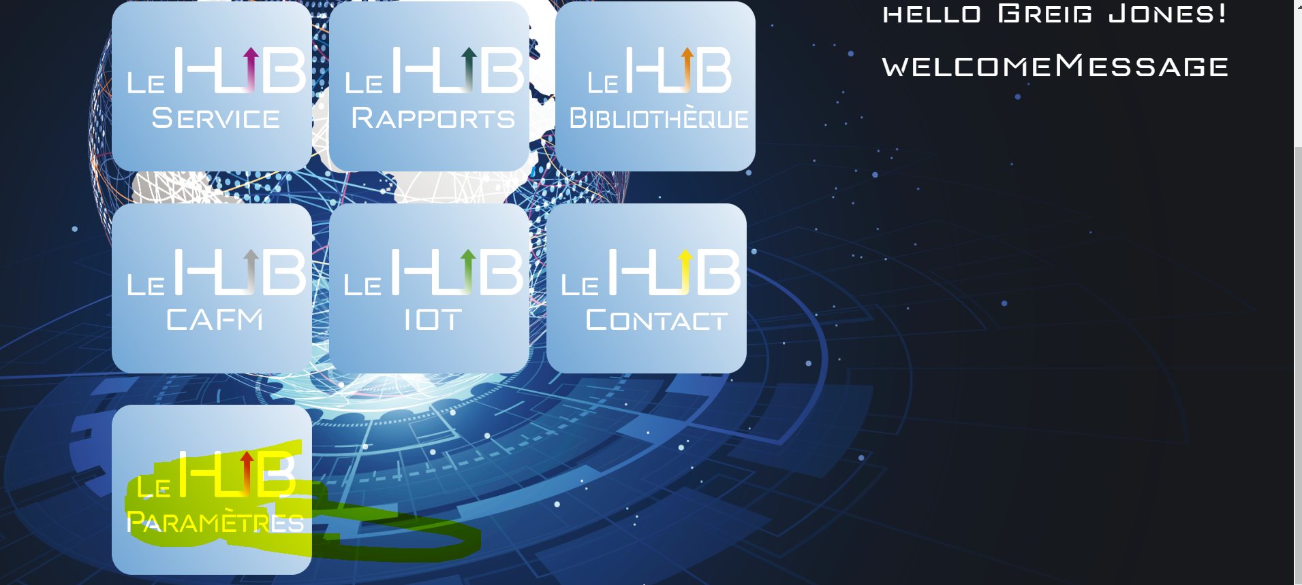

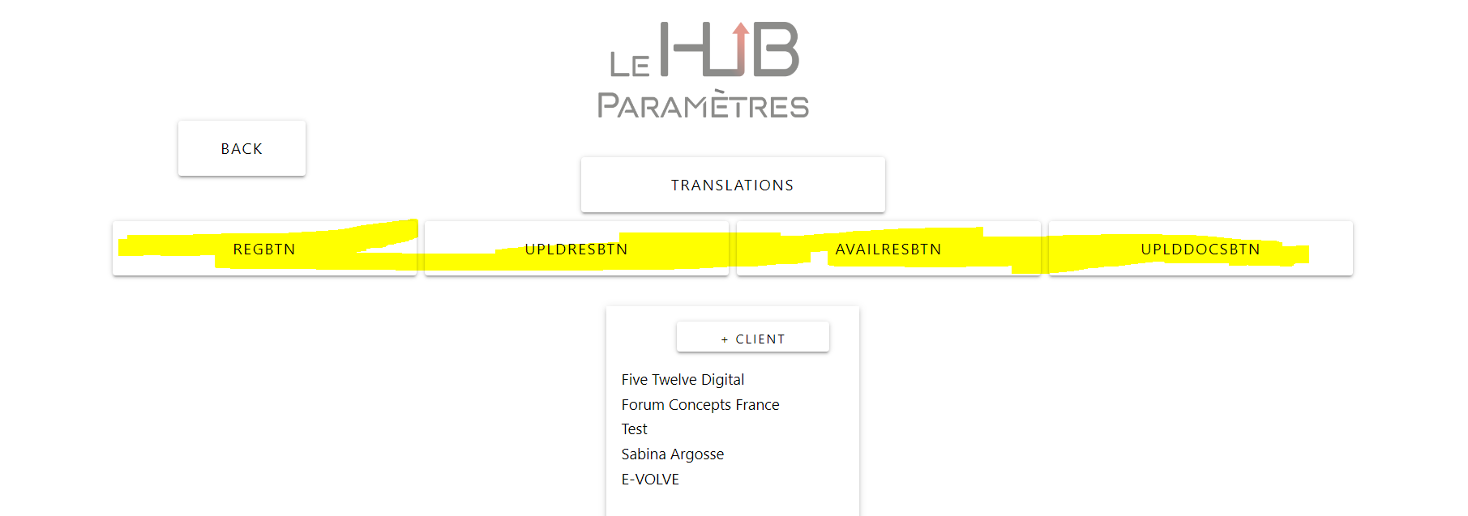

Can you check why ?

* The next point is when I click on any information below Client there is an error on the console.

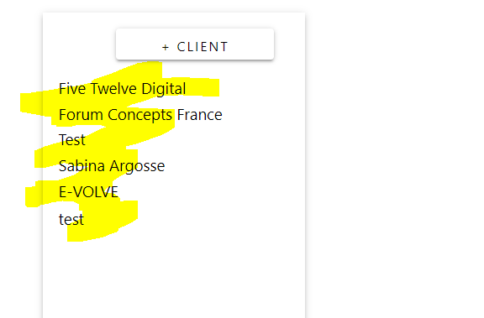

* On the page LeHuB Bibliotheque (https://show1.forumconcepts.fr/dashboard)

The upload of files is not working can you check the issue



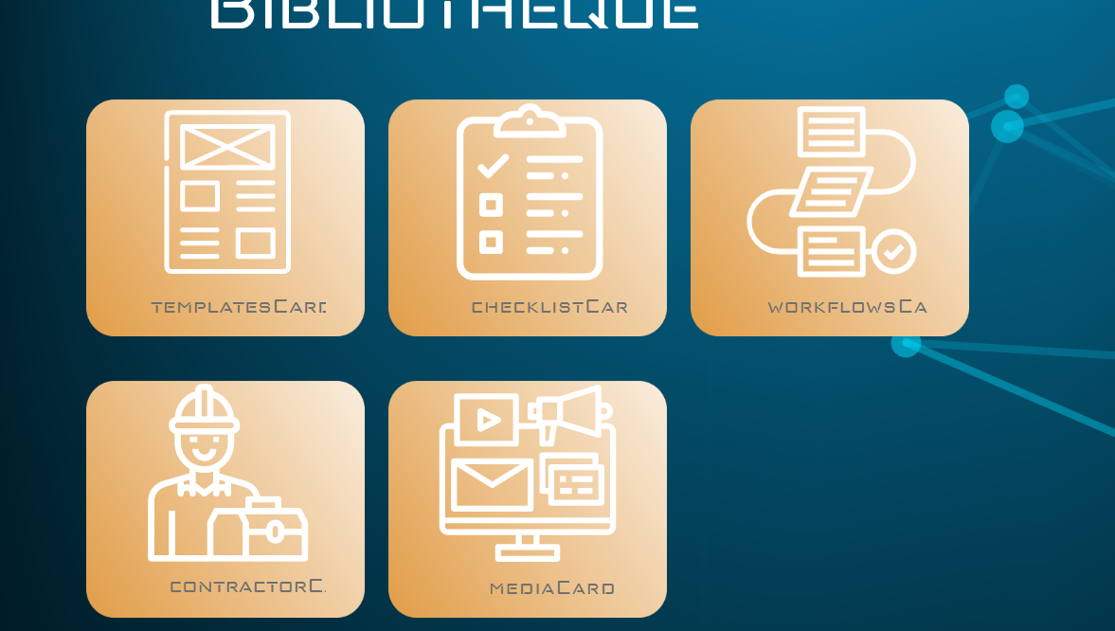

For now these are the only point to correct. We can do a meeting if you want whatApp me